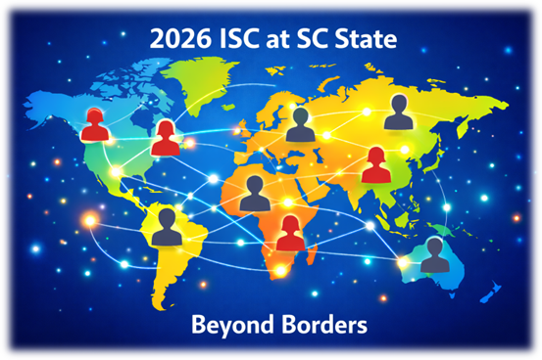
Call for Papers and Presentations
Conference Date: Friday, March 27, 2026 (8:00 a.m. to 5:00 p.m. U.S. Eastern DST via Zoom)
Deadline for Proposal Submission: Friday, February 27, 2026

The Department of English and Communications at South Carolina State University invites proposals for 20-minute individual papers, panels of 3–4 presenters, roundtable discussions, and creative performances or multimedia presentations for the 2026 SC State Intersectional Studies Remote Conference (ISC). In addition to proposals from faculty affiliated with higher education institutions, we welcome proposals from independent scholars, graduate students, and undergraduate students from all fields and disciplines.
This year’s theme is “Beyond Borders.” What does it mean to move beyond borders—geographical, epistemological, embodied, linguistic, disciplinary, or ideological—in ways that open space for intersectional engagement and justice? We invite proposals that explore, but are not limited to
• Borders and migration, displacement, diaspora, and transnationalism
• Borders of race, gender, sexuality, class, disability, nationality, citizenship, and other identities
• Colonial, imperial, and postcolonial boundaries
• Disciplinary borders and interdisciplinary methodologies
• Artistic, cultural, and digital practices that cross or contest boundaries
To submit a 250-word proposal, a 50-word description of your presentation, and a brief biographical note (50 words maximum) use the following link or QR code: https://www.surveymonkey.com/r/2025_ISC
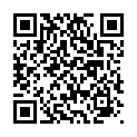
For questions about the ISC, contact Dr. Janice Hawes at jhawes@scsu.edu.

